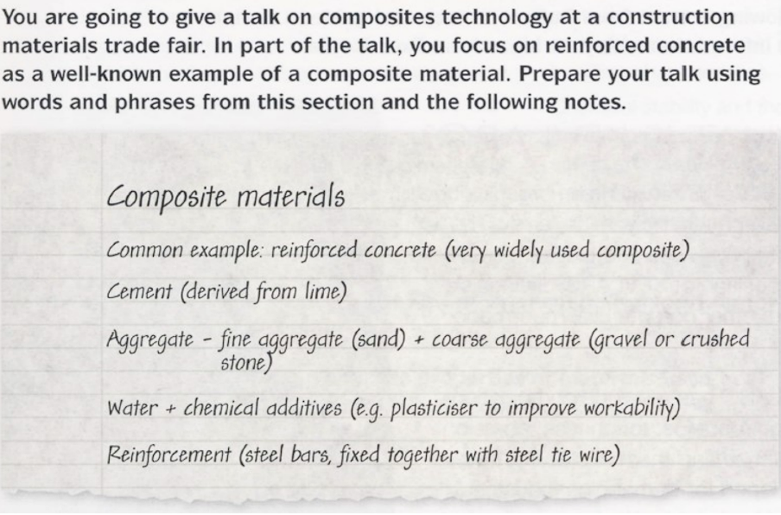

Composite materials consist of a combination of two or more materials.

A representative of this group is reinforced concrete, which is a very widely used composite material.

Reinforced concrete is made from cement obtained from lime, combined with aggregates that include fine aggregate such as sand and coarse aggregate such as gravel or crushed stone.

It also consist of water and chemical additives such as plasticizers to improve workability.

The strength is provided by steel reinforcement in the form of rods, which are fastened together with a steel tie wire.